IC TDA2007
CP039
Image:
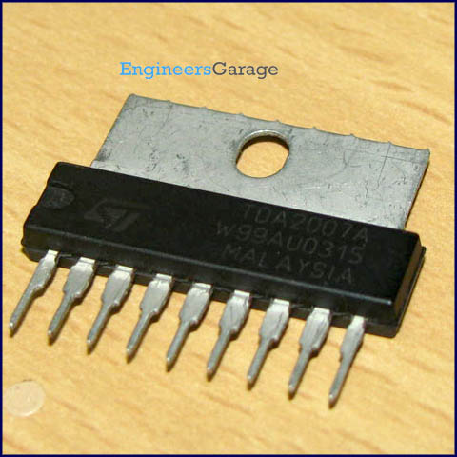
DataSheet:
TDA2007.PDF
TDA2007 is a class AB dual power audio amplifier. It amplifies the low power audio signals (mainly between 20 Hz – 20 kHz) to a higher level. The amplified high power audio signals are required to drive a loudspeaker in many devices. TDA2007 is mainly used for stereo applications in TV receivers, music systems and portable radios.

It has two channels for audio amplification. The amount of noise that a particular channel can reject from the supply voltage is indicated by its supply voltage rejection (SVR). It is simply the ratio of change in supply voltage to the corresponding change in output voltage of the amplifier. The SVR for each channel of TDA2007 is typically 55dB.

Pin Diagram:
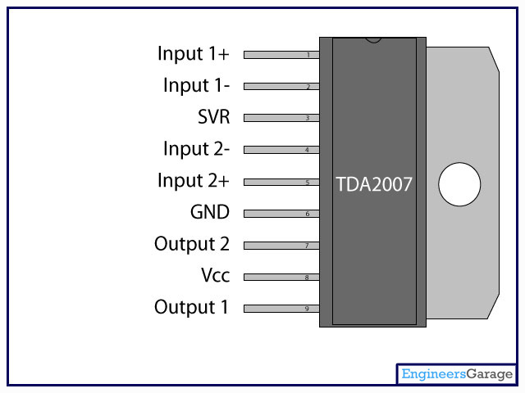
Pin Description:
Pin No | Function | Name
1 | Non-inverting input of 1st amplifier | Input1+
2 | Inverting input of 1st amplifier | Input1-
3 | Supply voltage rejection | SVR
4 | Inverting input of 2nd amplifier | Input2-
5 | Non-inverting input of 2nd amplifier | Input2+
6 | Ground (0V) | Ground
7 | Output of 2nd amplifier | Output2
8 | Supply voltage; 5V (up to 26V) | Vcc
9 | Output of 1st amplifier | Output

